**Step’s to perform**

1. Go to Backend Folder :-
   1. **npm install**
   2. **nodemon index.js : -** The server will started at port number 4000 and also creates a database named ‘evaluationSystem’.
2. **Add tables to database.**
   1. **using Mongodb Compass**
3. **connect to mongo db by clicking on connect button.**

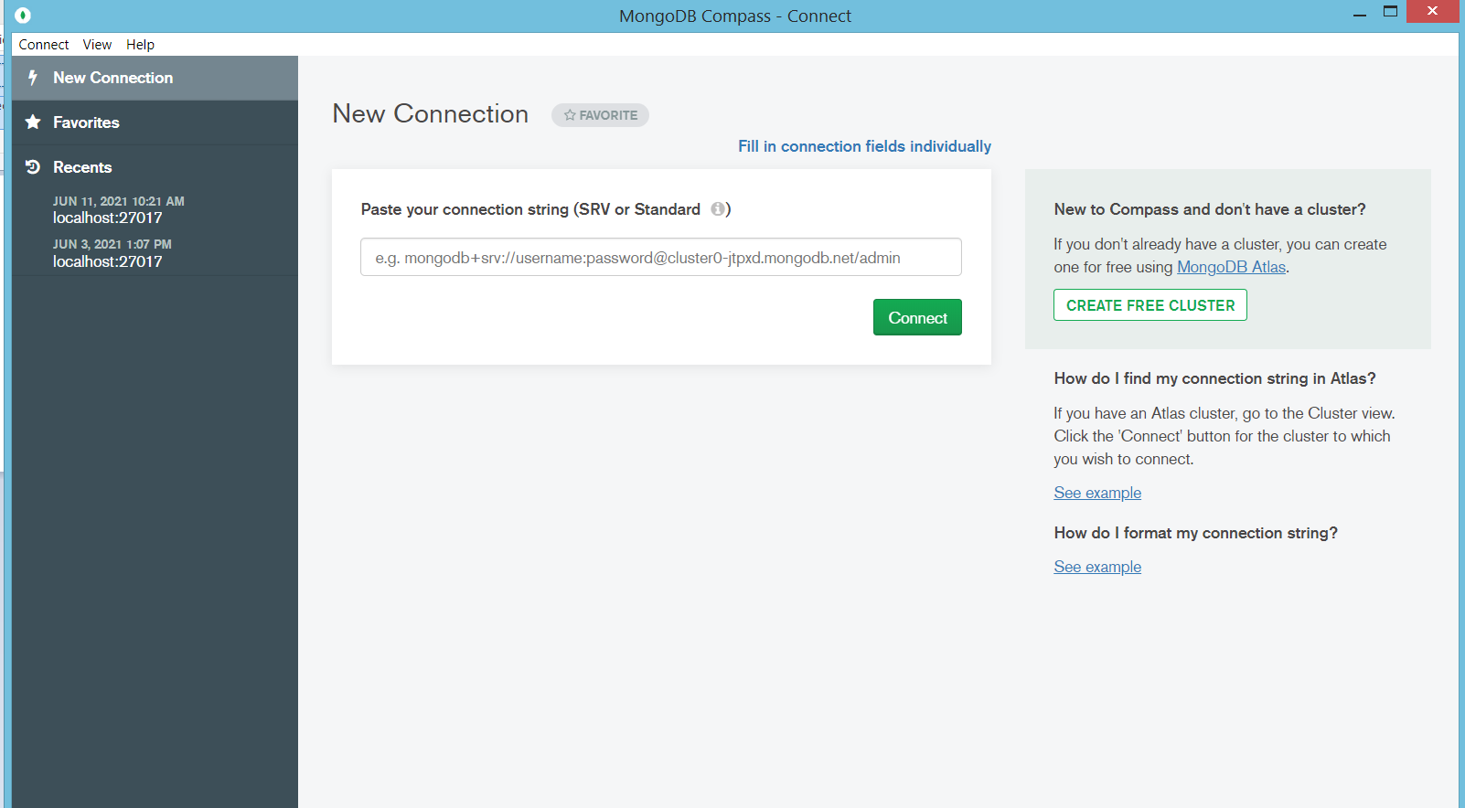

1. 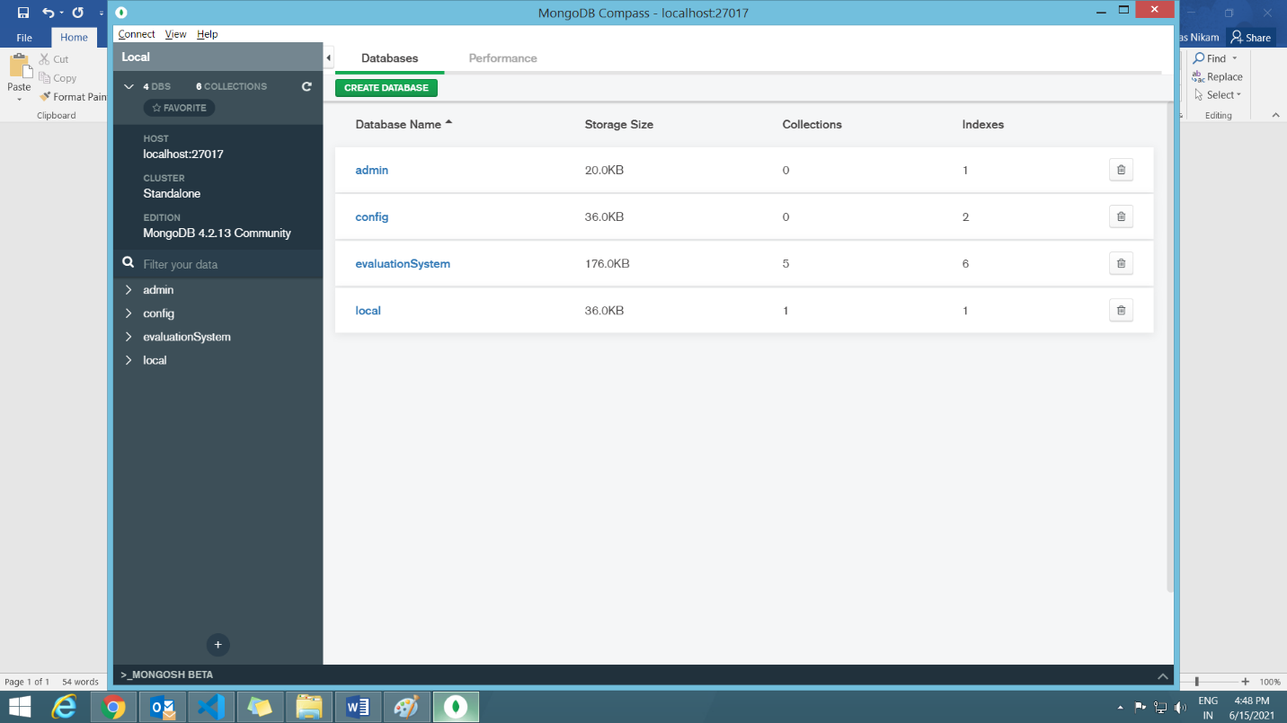**Select evaluationSystem**
2. 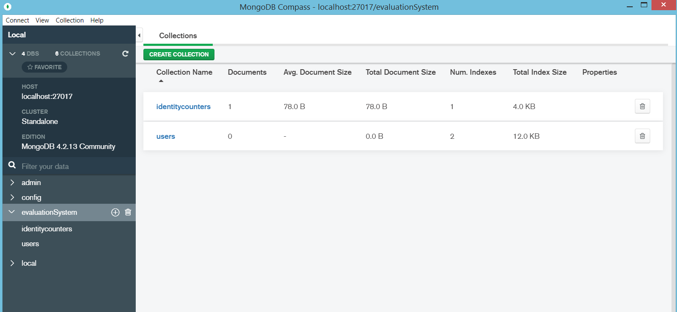**The screen will looks like this**
3. **From the above screen select the users collection.**

In the next window click on ADD DATA button then click on the Import File then the browse the users.json file present in BackendAPI folder and then click import.

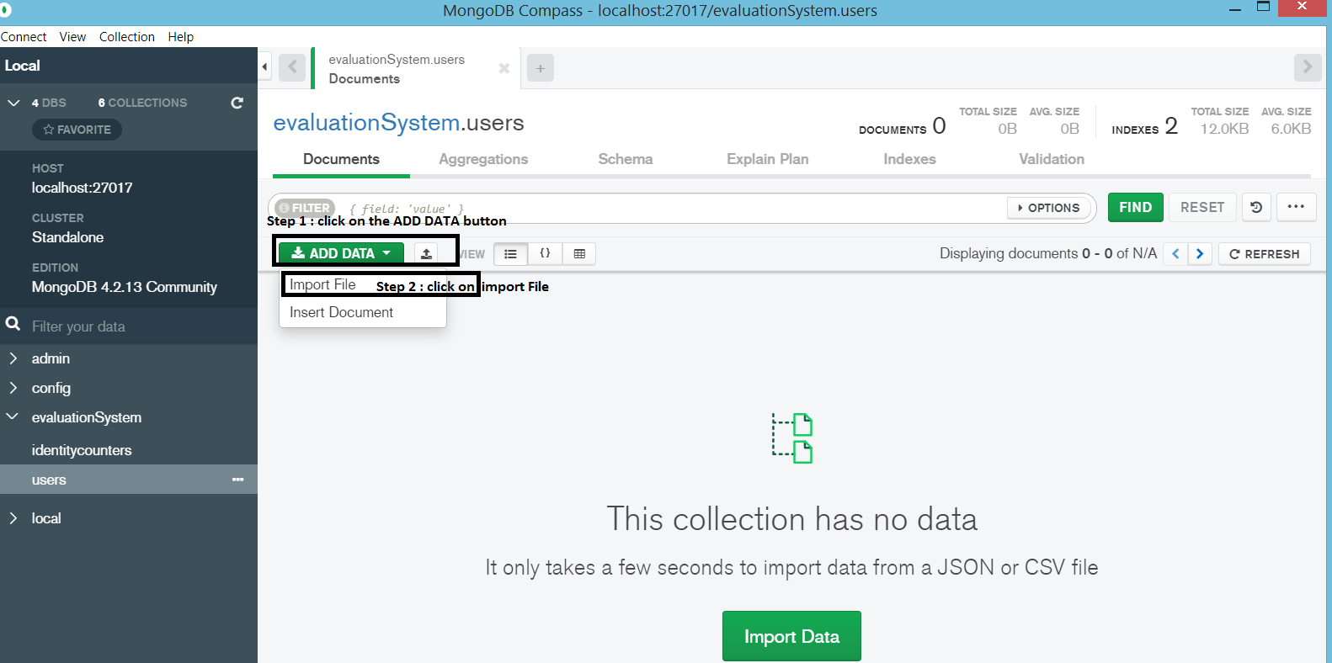

1. **After importing the users.json file go to the evaluationSystem and click on create Collection name the collection as ‘recruiters’ and click on create collection. The screen will look like the below screen shot.**

In the next window click on ADD DATA button then click on the Import File then the browse the recruiter.json file present in BackendAPI folder and then click import.

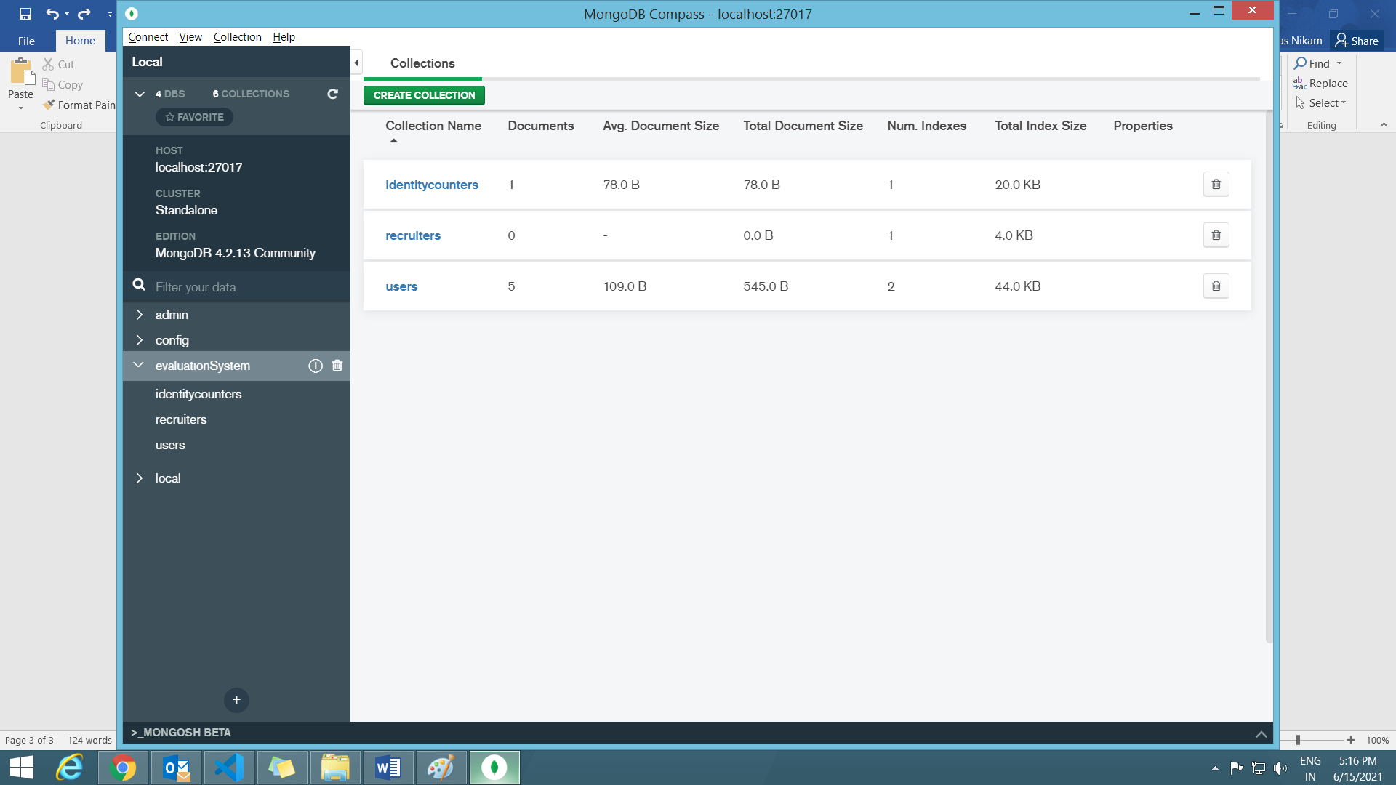

1. **After Importing recruiter.json,**

**create a new collection named as ‘skills’ and perform the similar steps but this time import the skill.json file from BackendAPI folder.**

* 1. 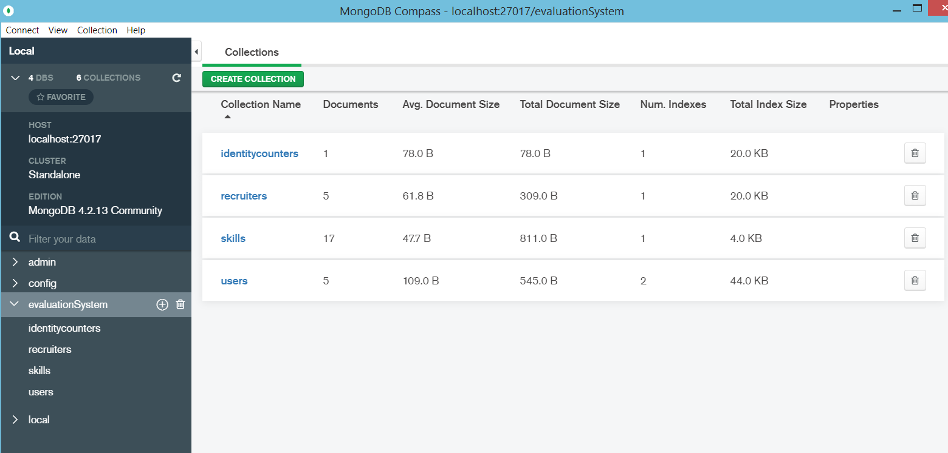**Using command prompt :-**

**If using command prompt open the command prompt from BackendAPI folder then use this command :**

1. **To import recruiters : -**

**mongoimport --db evaluationSystem --collection recruiters --file recruiter.json --jsonArray**

1. **To import skills :-**

**mongoimport --db evaluationSystem --collection skills --file skill.json --jsonArray**

1. **To import users : -**

**mongoimport --db evaluationSystem --collection users --file user.json --jsonArray**

1. **WEB COMPONENT : -**
   1. **npm install**
   2. **In constant\constant.ts file change the IP address with localhost**
   3. **npm run packagr**
   4. **After step b copy the Amadeus-hos-rec-boilerplate.tgz file into angular\evaluation folder.**
2. **Angular :-**
   1. **npm install**
   2. **npm install tc-comp-services**
   3. **npm install tc-comp-styles**
   4. **In app.service.ts file change the IP address with localhost everywhere.**
   5. **npm I Amadeus-hos-rec-boilerplate.tgz.**
   6. **After installing the package go to angular.json file and change the scripts name according to the name of boilerplate bundles.**